

z

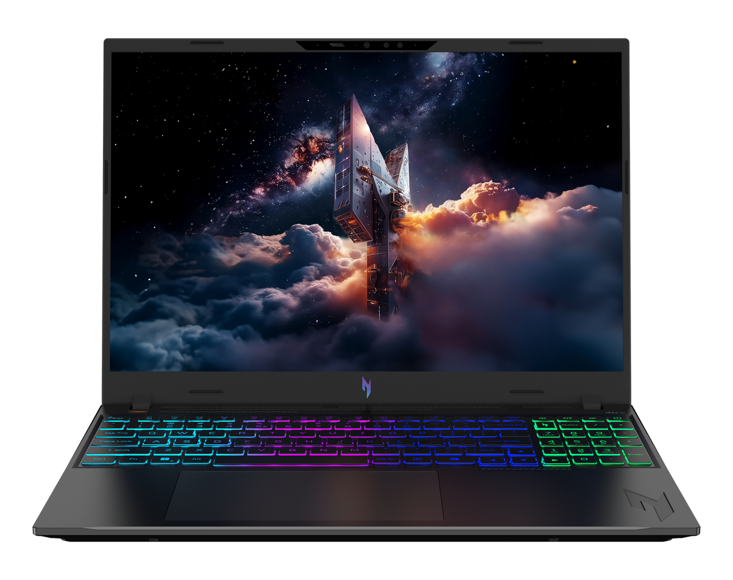

Acer Nitro V 16 AI

SPECIFICATIONS Acer Nitro V 16 AI ANV16-A71
Acer NITRO V 16S ANV16S-71

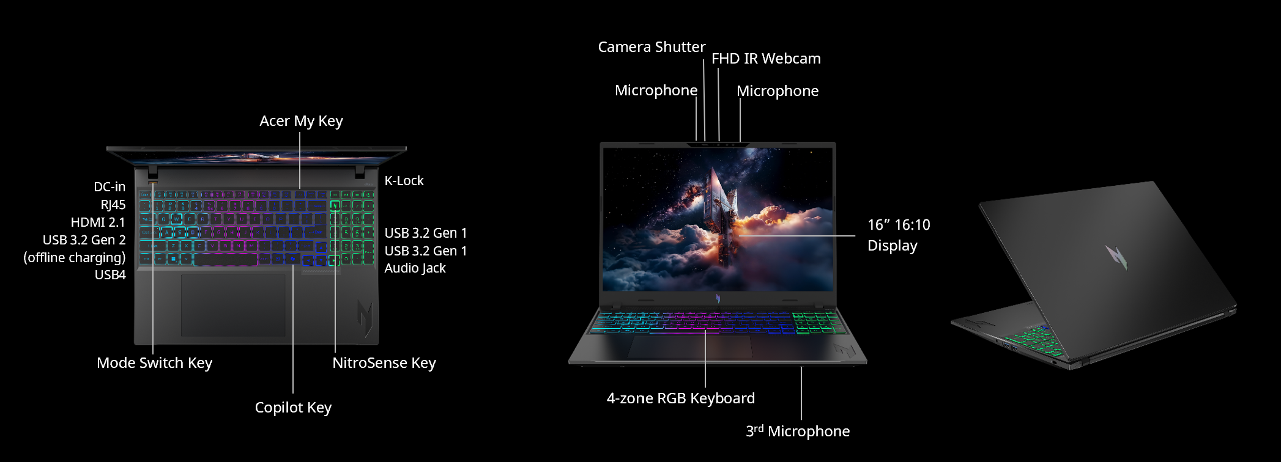
Operating System |  | Windows 11 Home
CPU and Chipset |  | AMD Ryzen™ AI 9 465  AMD Ryzen™ AI 7 450
Memory |  | Dual-channel DDR5 SDRAM support  Up to 32 GB of DDR5 system memory | Memory Frequency: Up to 5600 MT/s
Display |  | 16.0" display with IPS (In-Plane Switching) technology | WUXGA 1920 x 1200 | Acer ComfyView™ LED-backlit TFT LCD | 180 Hz refresh rate | 3 ms G to G response time with overdrive | NVIDIA® Advanced Optimus capable  - 16:10 aspect ratio  - 100% sRGB color gamut  - Wide viewing angle up to 170 degrees  - Ultra-slim design  - Mercury free, environment friendly
Graphics |  | NVIDIA® GeForce RTX™ 5060 8 GB GDDR7  NVIDIA® GeForce RTX™ 5070 8 GB GDDR7
Audio |  | DTS® X: Ultra Audio, featuring optimized Bass, Loudness, Speaker Protection with up to 6 custom content modes by smart amplifier |  |  | Supported in Windows Spatial Sound for PC Gaming with DTS  license integrated |  |  | Immersive audio rendering over headphones and internal speakers
 |  | High SNR DAC with 2.1 Vrms out capability and can driver high impedance headphone (up to 600 ohm)  Hi-Res Audio Certification by JAS (Headphone Output setting supported up to 24bit /192KHz) |  |  | Acer Purified Voice technology with AI noise reduction in dual built-in microphones. Features include far-field pickup, dynamic noise reduction through neural network, adaptive beam forming, and predefined personal and conference call modes. |  |  | Compatible with Cortana with Voice  Acer TrueHarmony technology for lower distortion, wider frequency range, headphone-like audio and powerful sound
Storage |  | Solid state drive (2 slots): 512 GB / 1 TB PCIe Gen4, 16 Gb/s, NVMe
Webcam |  | Video conferencing  UFC with narrow USB FHD camera and IR camera | Blue glass lens | 1920 x 1080 resolution | 1080p video with temporal noise reduction | Staggered high dynamic range (SHDR) | Dual microphones 33 mm + 33 mm | 88 x 3.2 x 2.6 mm | Windows compatible only
Wireless and Networking |  | WLAN:  Wi-Fi 6E Wireless LAN  802.11 a/b/g/n/ac/ax  Band: 2.4 GHz, 5 GHz, and 6 GHz  2x2 MU-MIMO technology | LAN:  Killer™ Ethernet E2600  10/100/1000 Mbps  Hibernation mode support  Wake On Lan support  IPv4 and IPv6 support |  |  | WPAN:  Supports Bluetooth® 5.4 or above
Security |  | Microsoft Pluton security processor | Firmware TPM solution | Camera shutter | BIOS passwords | User | Supervisor | Kensington lock slot
Dimensions and Weight |  | Dimensions  400.36 (W) x 258.13 (D) x 23.5/14.34 (H) mm (15.76 x 10.16 x 0.93/0.56 inches) with Plastic A Cover |  |  |  | Weight  2.5 kg (5.51 lbs.) with 4-cell battery pack, Full HD display
Power Adapter and Battery |  | Power Adapter  3-pin 180 W AC adapter  155.0 (W) x 76.0 (D) x 30.0 (H) mm (6.10 (W) x 2.99 (D) x 1.18 (H) inches)  588.5 g with 180 cm DC cable | Battery  76 Wh 4-cell Li-ion battery  For models with WUXGA Panel + SSD  Battery life:  Up to 6 hours (based on MobileMark® 2025 test results)
Input and Control |  | Keyboard  103 (US) / 104 (UK) / 107 (JP) keys | FineTip RGB-backlit keyboard | Independent numeric keypad | International language support  1.5 mm key travel  Programmable key | Acer My Key  Microsoft Copilot key  Dedicated NitroSense key  Special Nitro CMF keycap with transparent side view for enhanced RGB backlight performance  Caps Lock indicator  Microphone mute indicator  Function Lock key |  | Touchpad  Multi-gesture touchpad | Two-finger scroll | Pinch gesture | Gestures to open Cortana | Action Center | Multitasking | Application commands  Microsoft Precision Touchpad certification  Moisture resistant |  |  | Control Keys  Mode key  NitroSense key  Programmable key | My Key  Microsoft Copilot key
Windows Desktop Apps |  | In-House Applications  Acer AI Image Generator | Acer AlterView | Acer LiveArt | Acer ORD Service | Acer QuickPanel | Acer VisionArt  NitroSense V5 (NB) |  |  |  | Tools  Acer My Key Application | Amazon Alexa
Warranty |  | One-year International Travelers Warranty (ITW)
Disclaimers
• | Specifications vary depending on model.
• | Shared system memory may be allocated to support graphics, depending on system memory size and other factors. Actual system memory available to the operating system will be reduced by any memory used by the graphics solution and resources required by the operating environment.
• | Memory speed may vary, depending on the CPU, chipset or memory fitted.
• | All brands and product names mentioned herein include trademarks of their respective companies and are used solely to describe or identify the products.
• | 1 GB is 1 billion bytes. Actual formatted capacity is less and may vary depending on preloaded materials and operating environment. Acer Recovery Management uses a portion of the stated hard disk capacity as dedicated backup space.
• | Minor variations in system dimensions are possible due to the manufacturing process.
• | Weight may vary depending on product configuration, vendor components, manufacturing variability, and selected options.
• | Actual battery life may vary considerably by specifications, depending on product model, configuration, applications, power management settings, operating conditions, and features utilized. Performance variation also arises based on components in use, which includes but is not limited to the processor, RAM capacity, storage, display and resolution, etc.
• | Bundled software may vary depending on hardware configuration, OS and regional availability.
Product Sheet is based on Nitro ANV17-I31 Specifications (v2-0-1) (Preview)

